Lab sheet 2
CSS
Part 1:
- Give an example of inline CSS of your choice. (use at least 5 html elements)
- Give an example of internal CSS. (use at least 5 html elements)
- Give an example of external CSS. (use at least 5 html elements)
- Give an example of simple selector and grouping selector. (use at least 5 html elements).
- Design a webpage using <p> tag and <h1> tag and make font color red, background color yellow and font family “time new roman” for all element using universal selector.
- Design a webpage using attribute selector. Give proper example using:
  - CSS [attribute] Selector
  - CSS [attribute="value"] Selector
  - CSS [attribute~="value"] Selector
  - CSS [attribute|="value"] Selector
  - CSS [attribute^="value"] Selector
  - CSS [attribute$="value"] Selector3
  - CSS [attribute*="value"] Selector
- Design a webpage using pseudo class selector.
- Design a webpage using pseudo element selector.
- Design a webpage using combinator selector. Give proper example using:
  - Descendant selector
  - Child selector
  - Adjacent sibling selector
  - General sibling selector
- Design a webpage using background image with additional CSS properties like background-repeat, background-position, background-size.
- Design a webpage using border-style, border-color and border-width like below:
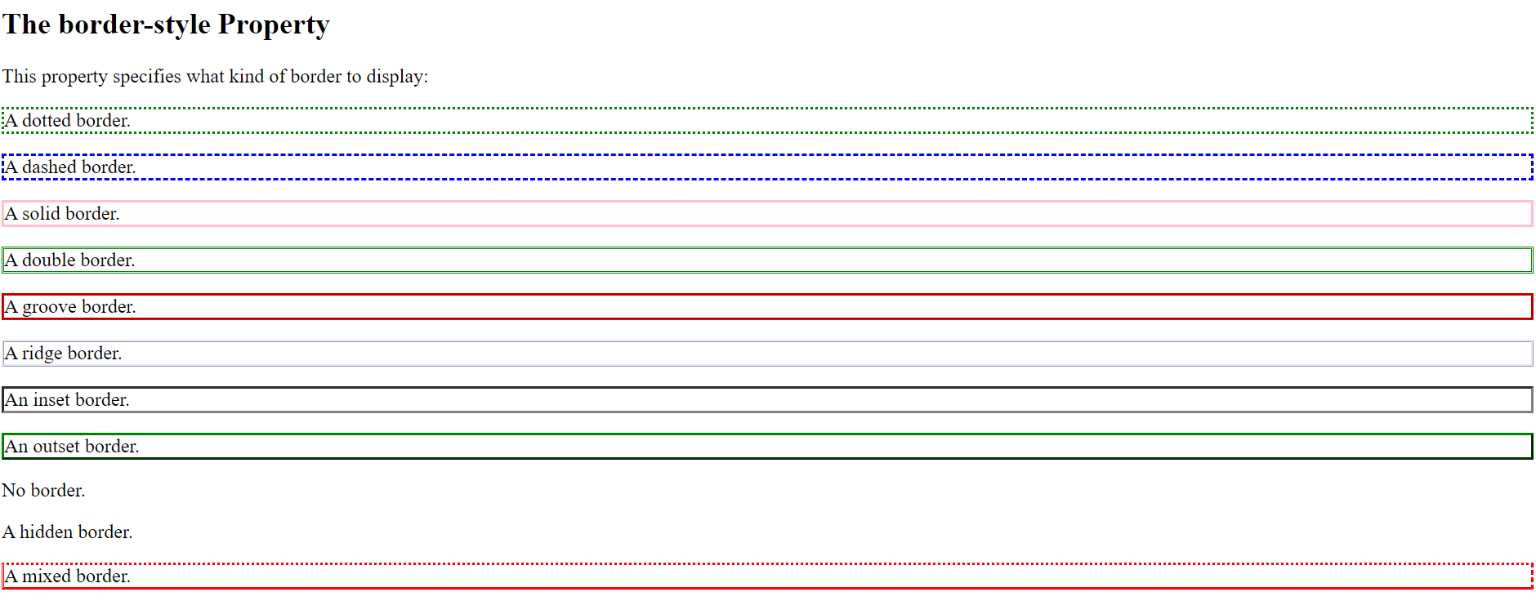
- Design a webpage using individual border style like below:
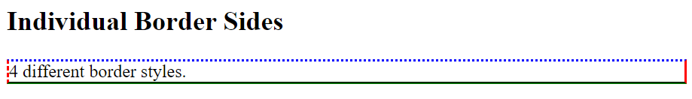
- Design a webpage using border-radius property like below:
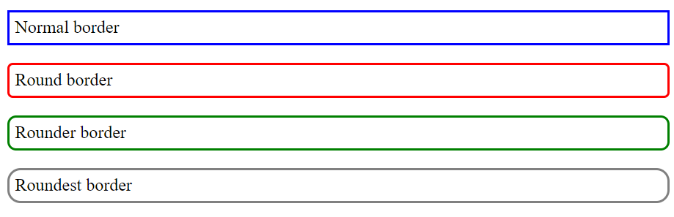
- Design a webpage using CSS margin property and also explore single value, two values, three values, four values, auto and inherit.
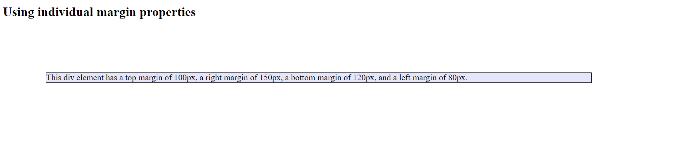
- Design a webpage using CSS individual padding property:
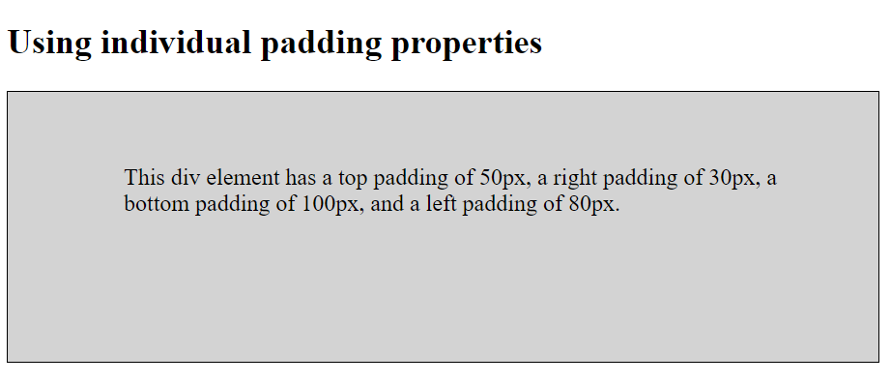

Part 2
- Give an example using text styling. (Use color, letter-spacing, word-spacing, text-align, text decoration, text-transform and text-shadow property).
- Design a webpage like below using css property:
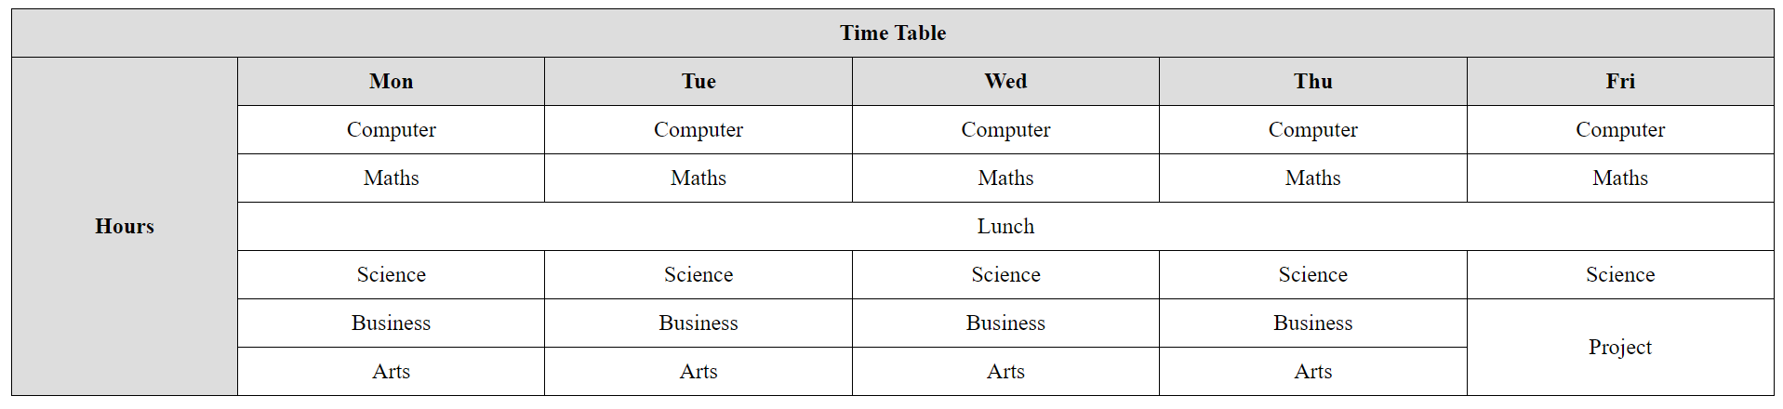
- Design a webpage like below using css property:
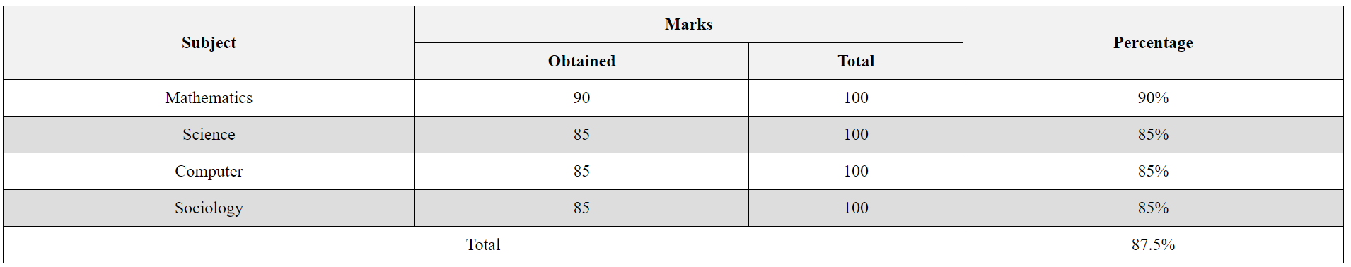
- Give an example using list-style-type, list-style-position and list-style-image.
- Design a webpage using <form> tag and CSS property.
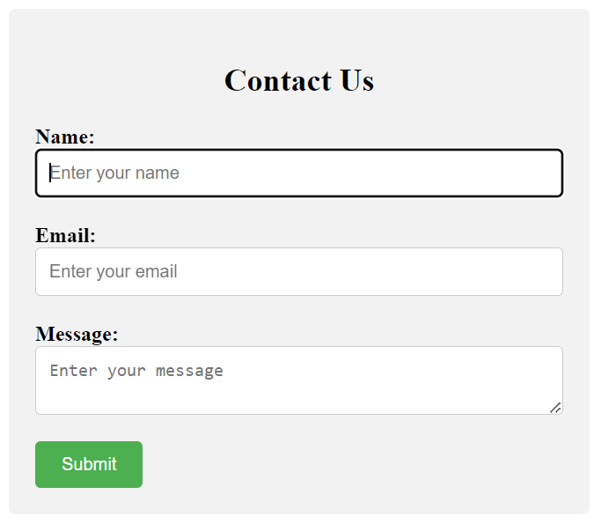

- Display a horizontal list of link using CSS display property.
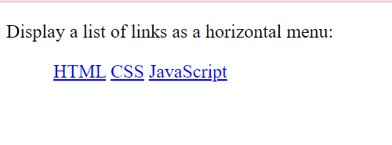
- Design a webpage using CSS Max-width property and find the difference between width and max-width.
- Design a webpage using CSS Overflow property. Make sure to explore values of overflow property which are hidden, visible, scroll and auto.
- Make small boxes using HTML elements and CSS. And use CSS float property with the value left or right.
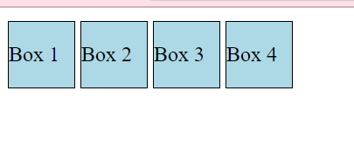
- Add icon to your HTML page with an icon library such as Font Awesome.
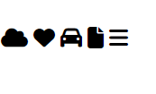
- Give an example using CSS Box-sizing property and see the difference between content box(default) and border box.
- Give an example using CSS Position property with static, fixed, sticky, relative and absolute value.
- Make 3 boxes and add position with z-index property and overlap the element.
- Give an example using media queries.

